Create a simple cloud software application for Property Buying &amp; Rental process (In Chennai city) using any Cloud Service Provider to demonstrate SaaS.

Aim :

To design and develop a simple cloud-based Flight Reservation System using Zoho Creator as a Software as a Service (SaaS) platform, enabling users to book, view, and manage flight reservations online.

Procedure :

- Logged in to Zoho Creator using a Zoho account.
- Created a new application named Flight Reservation System.
- Designed a form to enter passenger and flight details.
- Added required fields such as passenger name, flight number, source, destination, and travel date.
- Created a workflow to automatically set the booking status when a reservation is made.
- Generated reports to view all reservations and booked flights.
- Deployed the application on Zoho Cloud and accessed it through a web browser.
- Tested the application by entering sample flight reservation data.

Output :

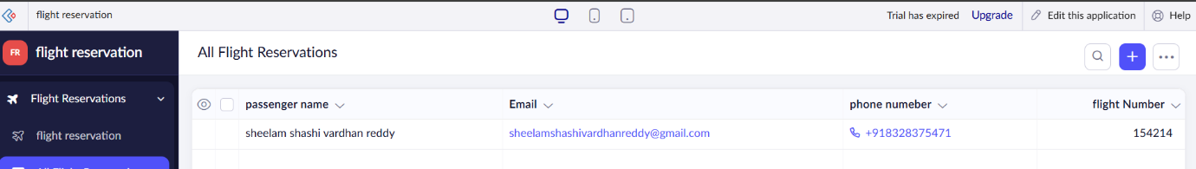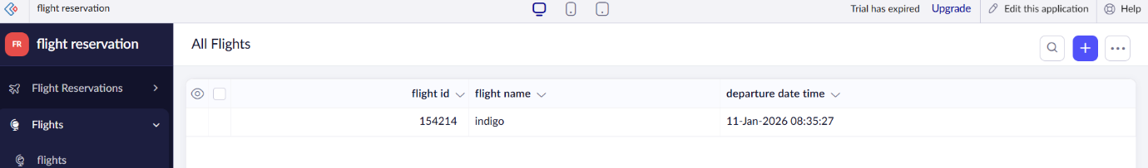

Result :

A cloud-based Flight Reservation System was successfully created and deployed using Zoho Creator. The application allows users to enter passenger and flight details, make reservations, and view booking information through a web browser. The system is hosted on the cloud and requires no local installation, thereby successfully demonstrating the Software as a Service (SaaS) model.

